⚙️ TurbineSense AI – GenAI Powered Turbine Health Monitoring & Predictive Analytics
TurbineSense AI is a unified AI system for gas turbine performance monitoring, emission prediction, predictive maintenance, and AI-driven decision support.
It combines:
✅ Classical predictive modeling (XGBoost)
✅ Time-evolving learning (Short-term model)
✅ Historical stability tracking (Long-term model)
✅ Generative AI troubleshooting assistant (LLM-based Chatbot)
✅ Interactive web dashboard (Streamlit)

🚀 Project Motivation
Gas turbines are critical assets in power generation and industrial systems. Their efficiency directly impacts energy output, fuel cost, and emissions compliance. However, due to harsh operating conditions and gradual performance degradation, failures are difficult to predict without proper monitoring.
TurbineSense AI solves this challenge by:
- Predicting Thermal Efficiency Yield (TEY)
- Monitoring emission drift (CO and NOX)
- Identifying early signs of degradation
- Supporting operators using an LLM-based troubleshoot assistant

✅ Key Features
Feature | Description
🔧 Predictive Modeling | TEY, CO, and NOX prediction
⏳ Short-term model | Learns recent turbine behavior (daily/weekly trends)
📈 Long-term model | Learns historical behavior (up to 5 years)
⚠️ Drift & Anomaly Alerts | Detects performance deviation and operational anomalies
🤖 LLM Chatbot | Helps operators troubleshoot using historical resolutions
📊 Visual Analytics | Interactive plots: Actual vs Short-term vs Long-term
🧠 Continuous Learning | Progressive model retraining
🌐 Easy UI | Launch via Streamlit—fully interactive

✅ System Architecture Overview
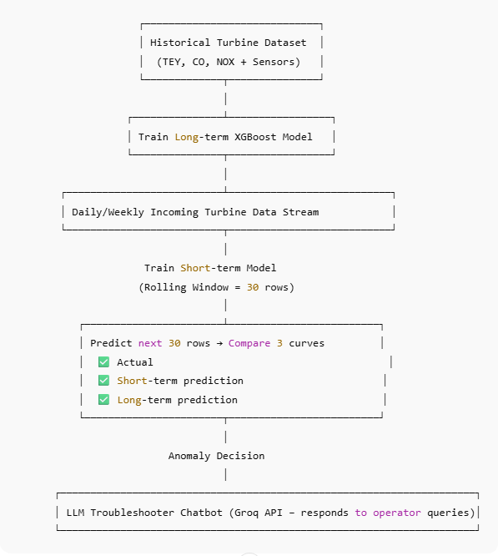

🔬 Prediction Logic
Rolling Training Cycle
- Take 30 rows → Train short-term XGBoost
- Predict next 30 rows using:
  - ✅ Long-term model
  - ✅ Short-term model
- Compare with actual measured values
- Repeat continuously → mimics daily turbine monitoring
Interpretation
Behavior | Meaning
Short-term 👍 & Long-term 👍 | Turbine is stable ✅
Short-term deviates, Long-term stable | Recent fluctuation but okay ⚠️
Both deviate ❗ | System drift → possible malfunction 🔧
Severe deviation 🚨 | Sudden anomaly – needs urgent attention

🧩 Tech Stack
Component | Technology
Frontend UI | Streamlit
ML Models | XGBoost (Short-term & Long-term)
AI Assistant | Groq LLM API
Data Handling | Pandas, NumPy
Visualization | matplotlib
Backend Architecture | Single file architecture (streamlit app.py)
Deployment | Local/Cloud

💻 How to Run
✅ Requirements
Install dependencies:
pip install -r requirements.txt
✅ Run Application
streamlit run app.py
✅ Enable Chatbot (Optional)
Enter your Groq API key in the sidebar 🔑 to unlock AI troubleshooting.
📈 Visual Outputs
✅ Actual vs Short-term vs Long-term
✅ Residual distribution for TEY, CO, NOX
✅ Prediction logs stored
✅ Batch performance analytics

🤖 Chatbot – AI Troubleshooter
This chatbot helps operators by:
✅ Explaining anomalies
✅ Suggesting corrective actions
✅ Learning from past maintenance history
✅ Running in parallel without affecting model training

🔮 Future Enhancements
- ✅ Dashboard level anomaly alarms
- ✅ LSTM / Transformer-based models
- ✅ Auto-report generator
- ✅ Digital twin integration
- ✅ Real-time SCADA input streaming

